**Vel Tech Multi Tech Dr.Rangarajan Dr.Sakunthala Engineering College**

**IoT Based Safety Gadget for Child Safety**

**Monitoring & Notification**

# Team ID : PNT2022TMID22515

**Team Members:**

**AJAY S**

**ARUL KUMAR A**

**CHENGAL NATHAN K**

**KARTHIKEYAN R**

# Abstract

The children are less secure nowadays and have many issues concerning their security purpose.Many Family members spent more time in work and social accountability where they need to take care of their children.The current status in our country is not habitable for monitoring children. With the absence of a child monitoring system, it is hard to monitor the children every seconds. Where Under age children may be impulsive in the way they act and in places to be. Most of the human behaviour are shaped in their childhood stage, In order to get this behaviour child monitoring system is necessary.Children are prone to many incidents and accidents. The safety of children is very indispensable as children cannot protect themselves.

The main aim of this project is to create a smart wearable device for children that uses refined technology to assure their safety. The paper provides a smart solution for deflecting losing kids while going out alone or with their parents based on the Internet of Things(IOT). Our proposed system will ensures utmost security and ensure live tracking for kids. It proposes a model for child safety through smartphones that can track their children’s location and provide the precise coordinates of the child’s location in real-time Anywhere by monitoring the activities, the security state of the children are examined.

# 1.INTRODUCTION

The Internet of Things (IoT) plays a vital role in day-today life. The Internet of Things is increasingly finding a place at the heart of many business automation strategies.Companies are using sensors in the logistics chain to help them track where delivery is with extraordinary accuracy. The motivation for this wearable comes from the increasing need for safety for little children in contemporary times as there could be scenarios of the child getting a drift in a major crowded sector.

This paper focuses on the key aspect that a missing child can be assisted by the people around the child and can play a remarkable role in the child’s safety until reunited with the parents. If any deviant readings are disclosed by the sensor, then an SMS and phone calls are set off to the parent's mobile. Also, it overhauls the parental app through the cloud. The technique is equipped with GSM and GPS modules for sending and receiving calls, and SMS between the safety gadget and the parental phones.

The system also consists of a Wi-Fi/cellular data module used to implement IoT and send all the monitored parameters to the cloud for android app monitoring on the parental phones. The panic alert system is used during panic situations alerts are sent to the parental phone, seeking help also the alert parameters are updated to the cloud. Most of the wearables available today are focused on providing the location, and activity of the child to the parents.

# 2.LITERATURE SURVEY

**{1} Authors: David Hanes, Gonzalo, Patrick Grosetete, Robert, Barton, Jerome**.

**Title: Henry “IoT Fundamental and Networking Technologies, Protocols”.**

During an emergency, mobile apps alert the control room of nearby police stations or caretakers of children. The literature shows that location tracking devices are available in the market but it does not provide a complete solution to the problem. The solution to this problem is to design an IoT device, which senses the child’s location and environment and during an emergency, it should send the alert to the parents automatically.

**{2} Authors: Aditi Gupta, Vibhor Harit. Published in: 2016 IEEE.**

**Title: Child Safety & Tracking Management System by using GPS.**

This paper proposed a model for child safety through smartphones that provide the option to track the location of their children as well as in case of emergency children are able to send a quick message and its current location via Short Message Services. Merits: The advantages of smart phones they offer rich features like Google maps, GPS, SMS etc. Demerits: This system is unable to sense the human behaviour of children.

**{3} Authors: Dheeraj Sunehera, Pottabhatini Laxmi Priya.**

**Title: Children.**

Location Monitoring on Google Maps Using GPS and GSM. Published in: **2016 IEEE**. This paper provides an Androidbased solution for parents to track their children in real time. Different devices are connected with a single device through channels of the internet. The concerned device is connected to the server via the internet. The device can be used by parents to track their children in real time or for women's safety. The proposed solution takes the location services provided by the GSM module. It allows the parents to get their child’s current location via SMS. Merits: A child tracking system using android terminal and hoc networks. Demerits: This device cannot be used in rural areas.

**{4} Authors: Khushalsing Rajput,Ankur Chavan.** Some of the existing works done on these similar lines are for example the low-cost, lightweight Wristband Vital which senses and reports hazardous surroundings for people who need immediate assistance such as children and seniors. The major drawback of the Vital band is that it uses Bluetooth as the mode of communication between the child and the parent.Since the distance between the two in some cases could be substantial and the Bluetooth just won’t be able to establish a close link between the two. Hence this system combines both GPS and GSM technology to provide a hand in such situations. The GPS is used for identifying the location and GSM is used for sending them a message

**{5} Authors: Omkar Tanawade, Swapnil Sonawane.** The absence of an information system which could display conditions, actual activity, and annual reporting of kindergarten students in a platform which could be accessed easily anywhere and anytime has led to a major block in the coordination of students, parents, and teachers. One of the most difficult technical implementations is how to compile and display

the updates of children’s position in a fast (near real-time) duration while accessed from outside communication.

**{6} Authors: Zambada J,Quintero R,Isijara R,Galeana R,**

**Santillan, L.(2015)**

Using the paradigm of IoT, the proposed sensors send data about the location to the Internet through a broker, as well as billions of objects in the world are sending their own data to the

Internet.

**{7} Authors: K. N. H. Srinivas, T. D. S. Sarveswara Rao, E.**

**Kusuma Kumari.**

**Title: Smart IoT Device for Child Safety and Tracking.**

Published in: 2019 IEEE. The system is developed using Link-It ONE board programmed in embedded C and interfaced with temperature, heartbeat, touch sensors and also GPS, GSM & digital camera modules. The novelty of the work is that the system automatically alerts the parent/caretaker by sending SMS when immediate attention is required for the child during an emergency. Merits: The parameters such as touch, temperature & heartbeat of the child are used for parametric analysis and results are plotted for the same. Demerits: To implement the IoT device which ensures the complete solution for child safety problems .

**{8} Authors: Akash Moodbidri, Hamid Shahnasser.**

**Title: Child safety wearable device. Published in: 2017 IEEE.** The purpose of this device is to help parents to locate their children with ease. At the moment there are many wearables in the market which help to track the daily activity of children and also help to find the child using Wi-Fi and Bluetooth services present on the device. Merits: This wearable over other wearables is that it can be used on any phone and it is not necessary that an expensive smartphone is required and doesn’t want to be a very tech-savvy individual to operate. Demerits: This device’s battery gives a short lifetime.High power efficient model will have to be used which can be capable of giving the battery life for a longer time.

**{9} Authors: M Nandini Priyanka, S Murugan.** The parent can send a message to the GSM module, according to the message information the GSM module replies back with particular details about the children. The location can be seen on Google Maps. When a particular child is facing an emergency situation, the device button should be pressed so that the device captures the image along with the user information to the enrolled mobile numbers. The life of the child can be saved within no time.

**{10} Authors: K N H Srinivas, T D S Sarveswara Rao, E Kusuma Kumari.**

From the children's point of view GPS, GPRS and GSM are used to monitor the speed and location tracking purpose. The system is fixed on the bus or car or in any vehicle so that the vehicle is going on a routine route or not can be identified by the GPS tracker, and the speed of the bus can also be extracted. Nowadays digital technology plays a major role in connecting people via the internet. For tracking the children, the androidbased solution is provided to parents. Internet is the one that will connect different components through a single device and is connected to the server. Parents track their children in real time with the location tracker by GSM.

# 3.EXISTING SYSTEM

In the existing system,we employ a voice recognition module where the child's alarm commands are recorded and retained for future use. In the event that the same child issues the same command, it will compare it to the alert command that was previously recorded and adjust the emergency level in accordance with the alert command. The GSM features a SIM that is used to phone or send alarm messages to persons you can trust. When necessary, GPS is used to track the current location. The server will look up the appropriate device ID in the database, look for the appropriate contacts using that device ID, and assist in notifying the registered guardians.

The project's drawbacks include the following:

1. The youngster could not accurately produce the alert order while experiencing a panic attack.

ii. The command generated might not coincide with the command previously stored. iii. Manual labour is needed for this job.

# PROPOSED SYSTEM

In the existing system, manual intervention was required.

But in the proposed system, we make every action autonomously.

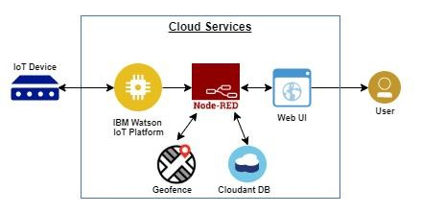

## Fig.1: Block diagram of the proposed system

We can use both web application as well as mobile application or either one of it as the front end user interface, cloud, and database as the back end for storing and retrieving information, and a device for monitoring.

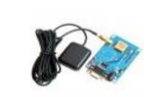

### Fig.2: GPS

GPS is used to track the live location of the child who is wearing that device. With the help of GPS, we can easily perform Geo-fencing concept, in which we will be able to feed a particular boundary to that device.

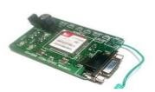

### Fig.3: GSM

If the child goes beyond that particular boundary specified, the respective guardians will receive an alert notification using

GSM. In our system, we use several components like,

1. GPS
2. GSM
3. IBM Watson Cloud
4. IBM IoT Platform
5. IBM Node RED
6. IBM Cloudant DB

Watson Studio allows you to train, deploy, and manage your AI models, and prepare and analyze information during a single integrated environment.



**Fig.4 :IBM WATSON CLOUD**

The Internet of Things (IoT) is the billions of physical devices around the world that are now connected to the internet, all collecting and sharing data. By combining IoT data with IBM Cloud technologies, business can extract valuable insights to improve virtually every aspect of their operations and enable innovative, new business models.

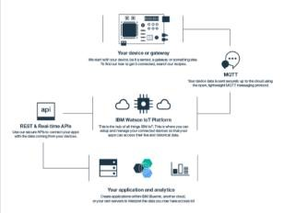

### Fig.5:IBM IoT Platform

NODE-RED is a stream based advancement instrument for visual programming and basically its main focus on visual apparatus for wiring the Internet of Things. This programming instrument is developed for wiring together equipment gadget(Hardware), APIs and online administrations in new and intriguing manners.



### Fig.6:IBM Node RED

IBM Cloudant allows queries to run against a single database that returns an array of matching documents and a bookmark, which allows access to the next block of search



**Fig.7:IBM Cloudant DB**

## WORKING

This proposed system focuses on the important idea that, up until they are reunited with their parents, those closest to a missing kid can help ensure their safety. An SMS and phone calls are sent to the parent's mobile phone if the sensor reports any abnormal values. Additionally, it updates the parental app via the cloud. The method includes GSM and GPS modules for SMS and call communication between the parental phones and the safety device.

A Wi-Fi/cellular data module is also part of the system, which is utilised to integrate IoT and send all the observed parameters to the cloud for parental phones to monitor.

When a panic attack occurs, the panic alert system is utilised to send alerts to the parent's phone and request assistance while simultaneously updating the alert parameters in the cloud. The majority of wearables on the market today are designed to inform parents about the whereabouts and activities of their children.

## RESULTS IBM WATSON IOT PLATFORM The Watson IoT platform to find the In-Area and out-Area Locations

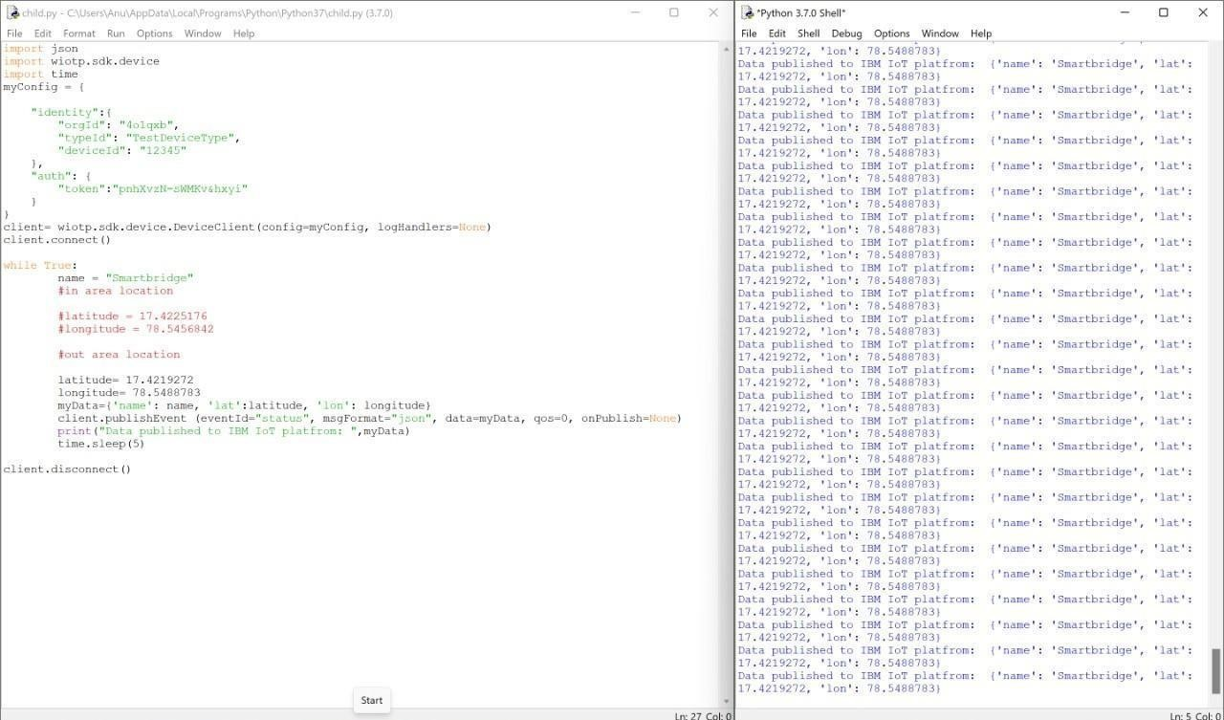

## Fig.8:Out-Area Location

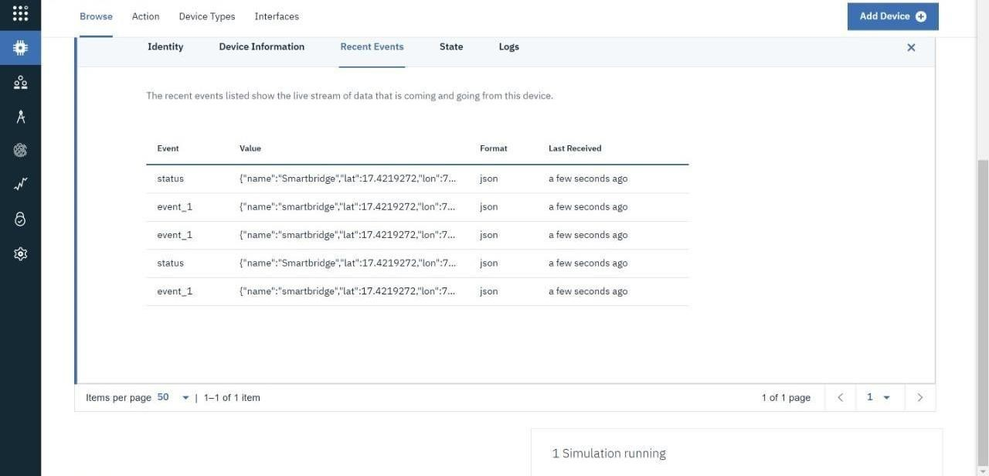

## Fig.9:IBM Watson IoT NODE-RED SERVICE

**In Node-RED Service ,first to create the node**

**connections and then code in each of the nodes.**

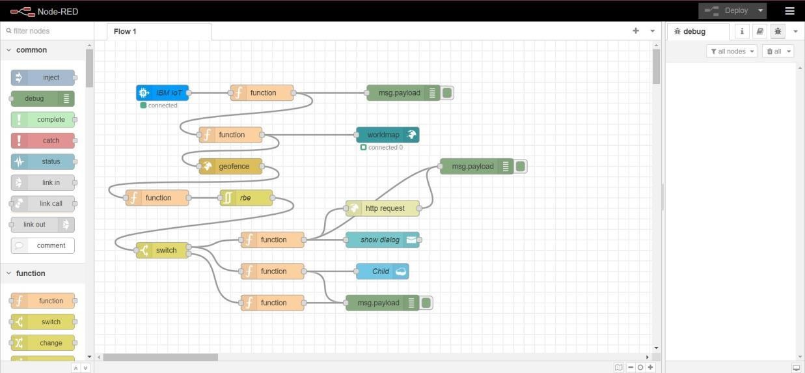

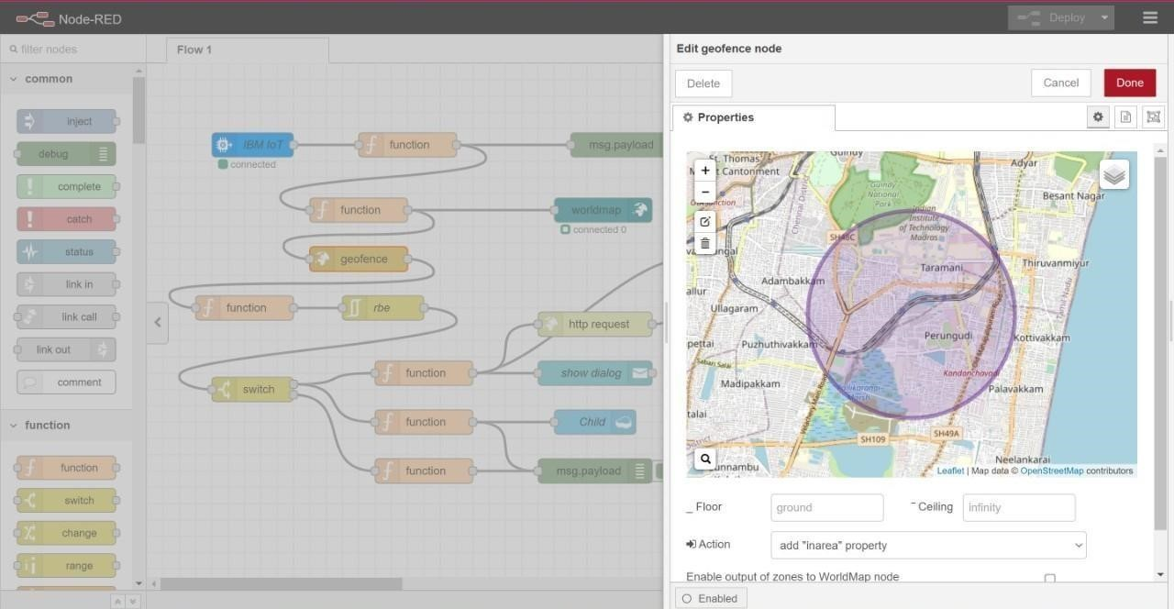

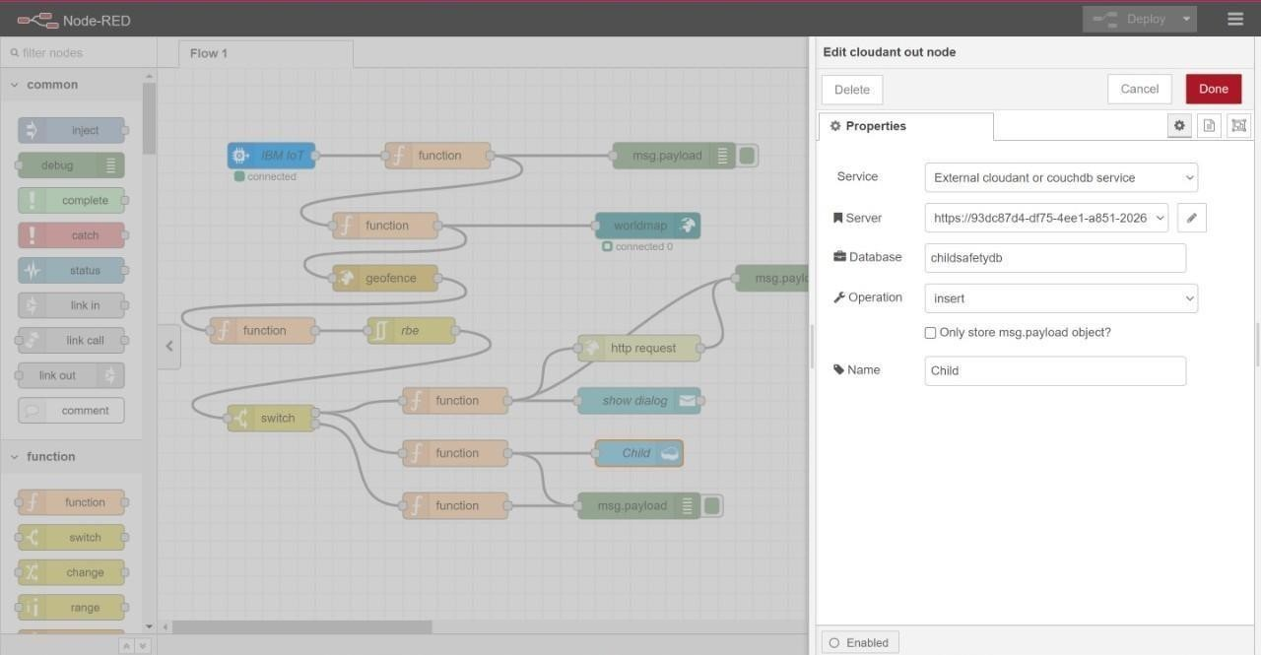

## Connecting with IBM Cloud: Using IBM IOT node through the API key

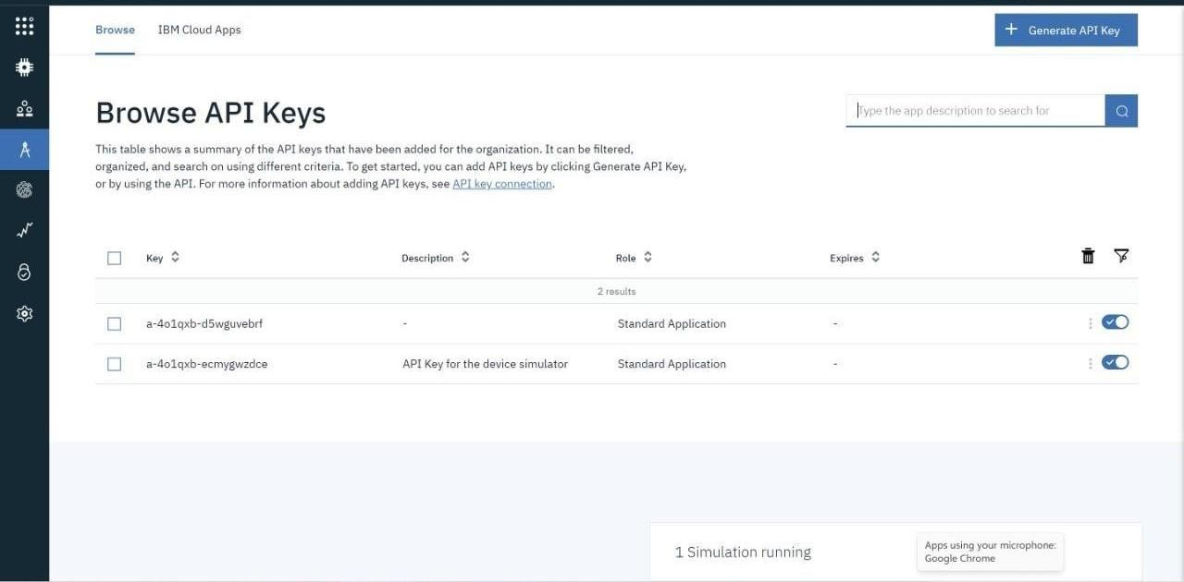

Transferring values from Python Code:

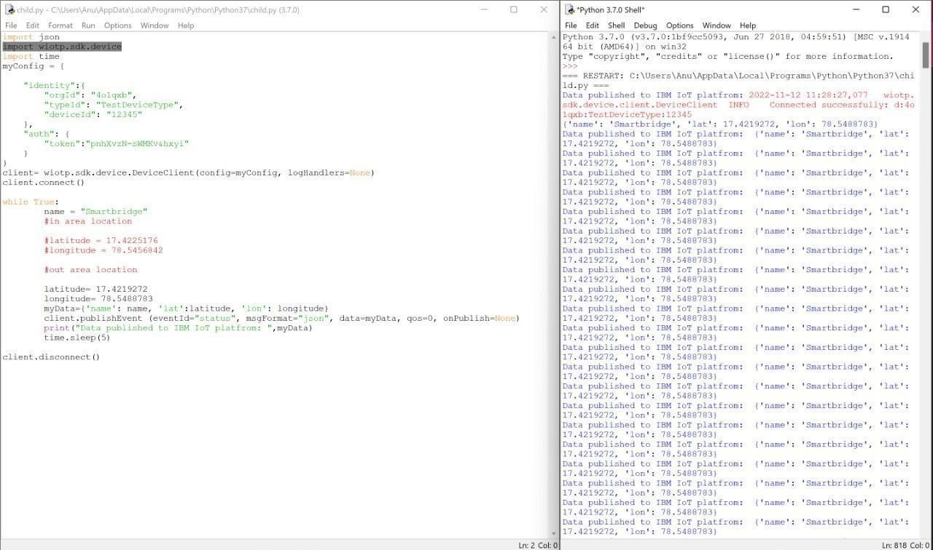

**Node-Red:**

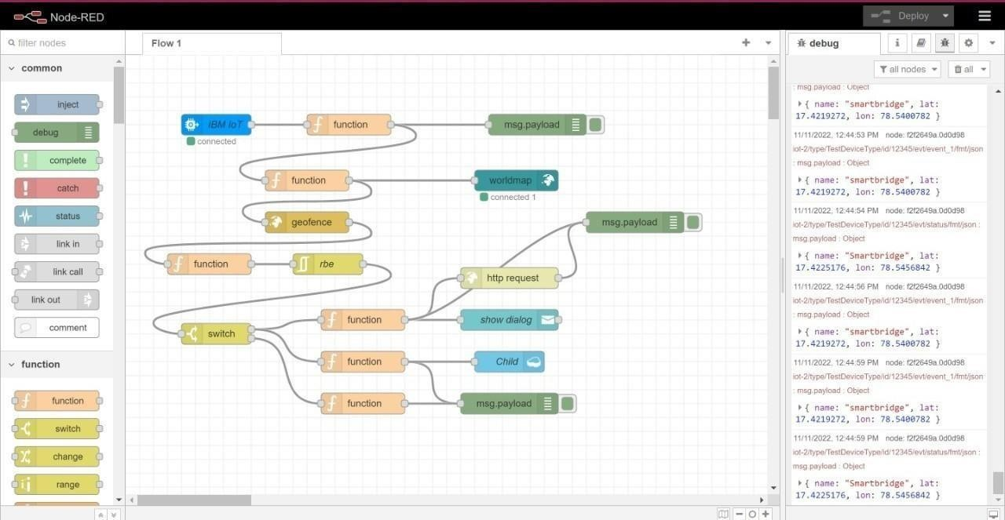

## Creating Cloudant DB and integrating Node-Red with the Web UI

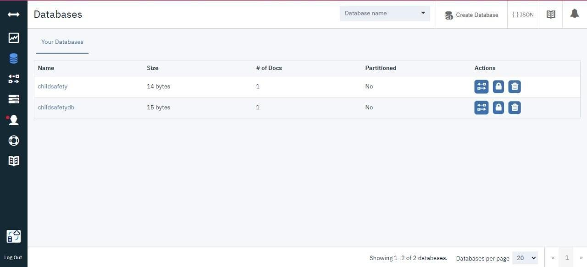

Node-Red Service with Cloudant Database:



Node-RED Dashboard(Web ui):

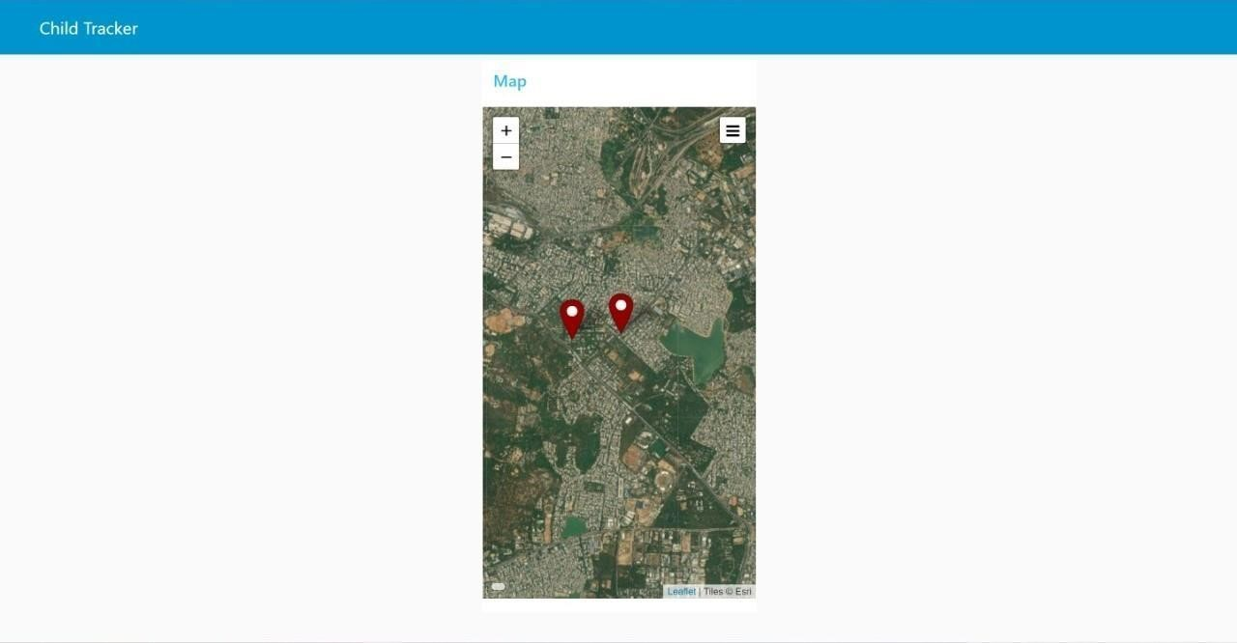

Creating the MIT app and Showing the child's location Create App in MIT App inventor:

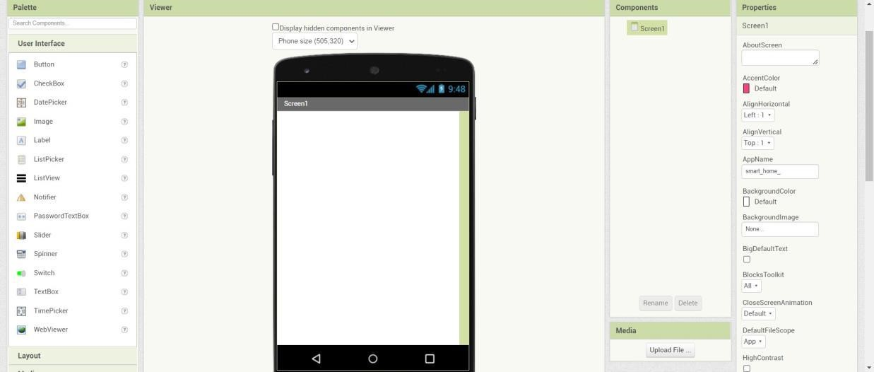

Block Configuration:

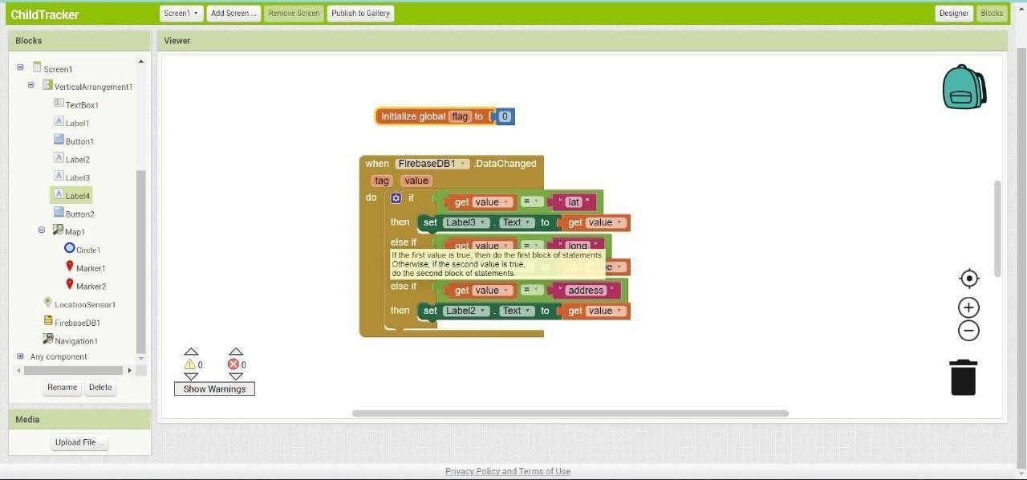

Output(App inventor):

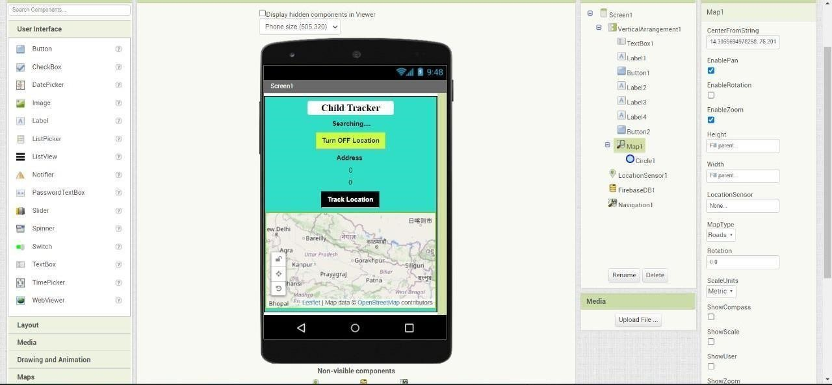

Location Status:

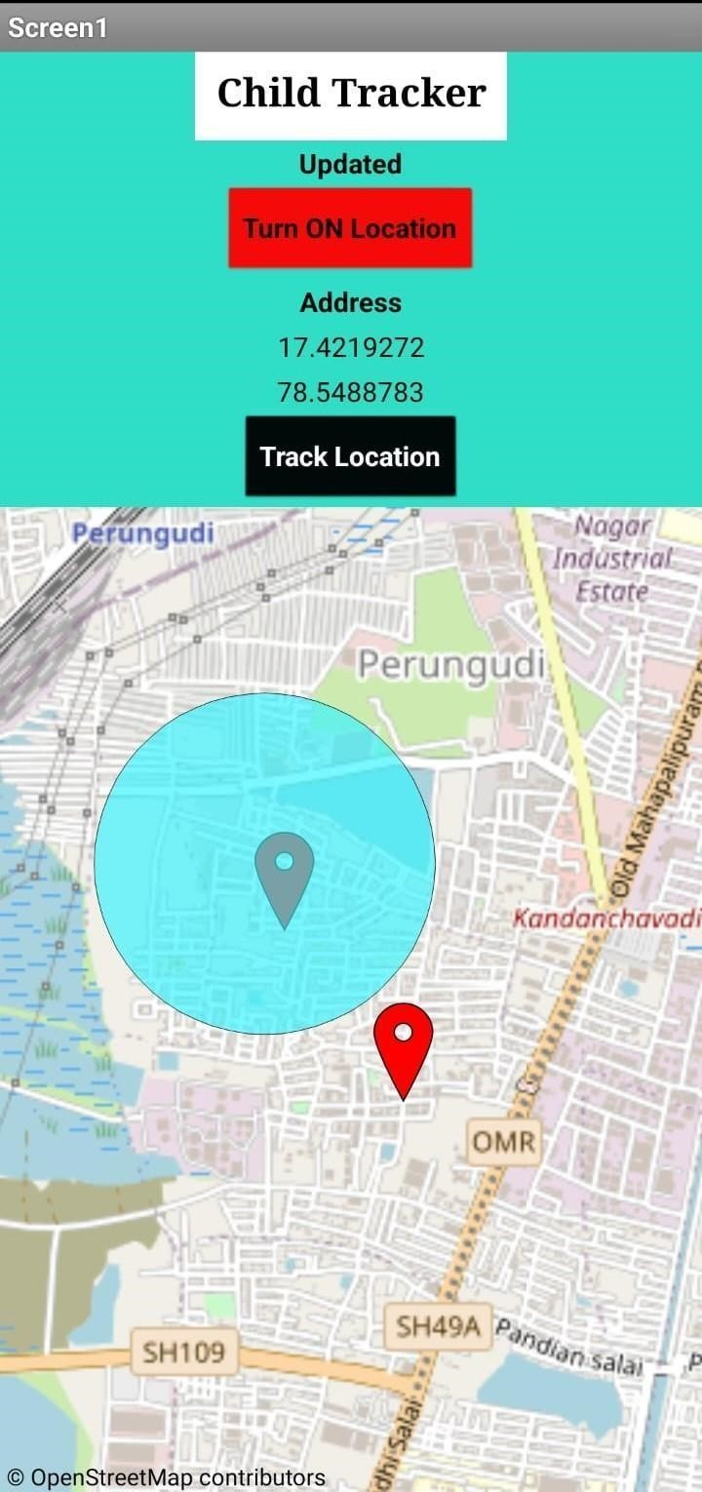

## CONCLUSION

This paper to ensure the safety of children and increase their confidence. Many experimenters are operating in this area and have formulated different technologies to aid children. The key represented in this paper takes the advantage of smartphones which proposes affluent elements like Google maps, SMS, etc. The child safety and protection device is proficient in acting as a smart IoT device. It equips parents with real-time location, the surrounding temperature, and along with an alarm buzzer for their child’s circumstances and the capability to locate their child. This paper depicts the fundamental design concept and functionality along with the anticipated consequences.

# REFERENCES

1. AnandJatti, MadhviKannan , Alisha RM, Vijayalakshmi P, ShresthaSinha, " Design and Development of an IOT based wearable device forthe Safety and Security of women and girl children “, IEEE International Conference On Recent Trends In Electronics Information Communication Technology, May 2021, 2016, India.
2. " RFID-based System for School Children Transportation Safety Enhancement ", Proceedings of the 8th IEEE GCC Conference and Exhibition, Muscat, Oman, 1-4 February 2015.
3. Pooja.K.Biradar1, Prof S.B.Jamge2,” An Innovative

Monitoring Application for Child Safety”, DOI:10.15680/IJIRSET.2015.0409093.

1. AkashMoodbidri, Hamid Shahnasser, ”Child Safety Wearable Device”, Department of Electrical and Computer Engineering San Francisco State University.
2. Dr. R. Kamalraj, ” A Hybrid Model on Child Security and Activities Monitoring System using IoT”, IEEE Xplore Compliant Part Number: CFP18N67-ART; ISBN:978-1-53862456-2.
3. Sarifah Putri Raflesia, Firdaus, Dinda Lestarini, “An

Integrated Child Safety using Geo-fencing Information on Mobile Devices", INTERNATIONAL CONFERENCE ON ELECTRICAL ENGINEERING AND COMPUTER SCIENCE

(ICECOS) 2018.

1. Prof. Sunil K Punjabi, Prof. Suvarna Chaure, "Smart Intelligent System for Women and Child Security” Department of Computer Engineering SIES Graduate School of Technology Nerul, Navi Mumbai, India.
2. Zejun Huang1, ZhigangGao,” An Mobile Safety Monitoring System for Children”, 2014 10th International Conference on Mobile Ad-hoc and Sensor Networks.